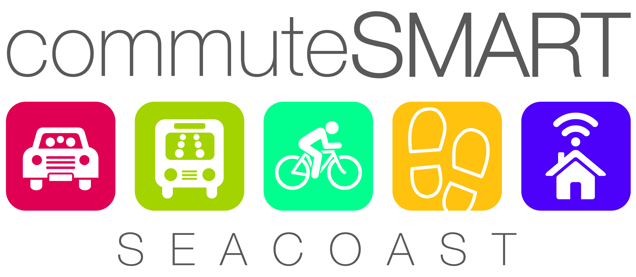
Thank you for your interest in joining commuteSMARTseacoast!
Please complete this form and return to arugg@commuteSMARTseacoast.org

MEMBERSHIP FORM
Company Name Click here to enter text. Date Click here to enter a date.
Street Address Click here to enter text. City Click here to enter text. State Click here to enter text. Zip Click here to enter text.
Contact person Click here to enter text. Title Click here to enter text.
Email Click here to enter text. Phone Click here to enter text.
Number of employees Click here to enter text. (full time) Click here to enter text. (part time)Click here to enter text.

Please check the FREE commuteSMARTseacoast services you are interested in receiving:
Click here to enter text.Surveying and analyzing employee commuting patterns and needs
Click here to enter text.On-site event with information on commuting options and sign-up for carpool matching
Click here to enter text.Information on regional commuter events/contests (e.g. Seacoast B2B Commuter Challenge, Bike/Walk to Work Week, Try Transit Week,)
Click here to enter text.Emergency Ride Home benefit.
Click here to enter text.Quarterly E-newsletter

For more information, contact Anne Rugg, 603-743-5777 x.109 or 603-953-3176
arugg@commuteSMARTseacoast.org www.commuteSMARTseacoast.com

