Weekly Cheerleading Guide
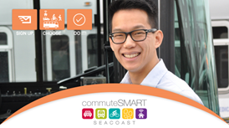 Click here to download poster.
Tuesday, April 4th
EMAIL BLAST #1: “Join the Commute Smart B2B Challenge May 1st – 31st!”
Did you know our company is competing in the upcoming Commute Smart B2B (Business to Business) Challenge? It’s a fun contest to use sustainable transportation during the month of May.
All you have to do is commute to work using any mode other than driving alone (e.g. carpooling, riding your bike or moped, walking, taking the bus, or working from home). You register online and then log your trips throughout the month. You don’t have to commute smart every day...whatever works for your schedule.
You’ll get cool swag, a coffee gift card, and a chance to win raffle prizes. Plus money in your pocket from savings on gas, tolls, and vehicle maintenance.
Not sure about sustainable commuting options? For more information and commuting tips
click here or call Anne Rugg at 603-953-3176. Click this link to join our team and be part of the smartest, greenest workforce.

Your wallet and your planet will thank you!
Sincerely,
XXXX
Captain, Team XXXXX

P.S. Getting to work has never been so much fun!

Tuesday, April 11th
Resend Email blast #1 with a P.S. “If you’ve already signed up, thanks so much!”

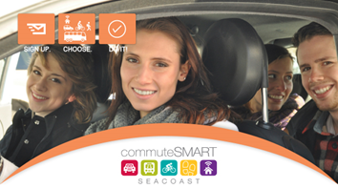 Click here to download poster.
Tuesday, April 25th
EMAIL BLAST #2: “Don’t miss out – only 1 week left”
Don’t miss out!
There’s only one week before the Commute Smart B2B Challenge! It kicks off next Monday, May 1st^{th} and runs through May 31st.
Click this link to join our team and be part of the smartest, greenest workforce by carpooling, bicycling, walking, bicycling, taking the bus, or teleworking!
Get swag and win prizes!
Getting to work has never been so much fun!
P.S. If you’ve already joined our team, thanks so much!

Click here to download poster.
Monday, May 1st
EMAIL BLAST #3: “Let the games begin!”
Today is the first day of the Commuter B2B Challenge! Thanks so much for joining our team.
Your pocketbook and your planet thank you for commuting smart.
You log your trips here. As the Challenge progresses, you will see how our team stands in real time ranking. When you click on our team name, you’ll see your individual ranking.
Getting to work has never been so much fun!

P.S. Do you have anything to share on social media about your smart commute? Use #CommuteToWin and our company name. We could win a prize for most social media buzz! Highlights of the social media posts are found below the Challenge leaderboard.

Tuesday, May 9th No poster.
Email blast #4: “Having fun commuting smart!”
It’s Week Two of the Commuter B2B Challenge and we’ve got X# people on our team! We are carpooling, bicycling, walking, taking the bus, and teleworking (you may need to edit these options) to save money and help the planet, and get exercise. Now that’s smart!
Are you getting into the habit of logging your trips? Most folks do it as they start their work day in the morning or during lunch.
If you haven’t received your “Thanks for Logging your First Trip” bag ‘o swag, please (insert instructions here)
P.S. Do you have anything to share on social media about your smart commute? Use #CommuteToWin and our company name. We could win a prize for most social media buzz! Check out highlights of the social media posts below the Challenge leaderboard.

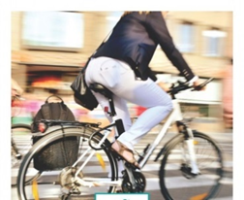 Click here to download poster.
Tuesday, May 16th
Email blast #5: “New smart commuter swag has arrived!”
Thanks for commuting sustainably during the last two weeks! You are doing your part to help reduce carbon emissions and put money in your pocket. Verysmart!
We have a new swag from commuteSMARTseacoast! (Insert your pick up or delivery instructions. )
Are you keeping up with logging your trips? If you don’t log, it didn’t happen!
P.S. The more trips you’ve logged, the better your chances for winning one of our cool raffle prizes next week.

Tuesday, May 23rd No poster
Email blast #6: It’s raffle time for smart commuters
More fun this week for smart commuters – a raffle with some great prizes will be held on _____.
The more trips you logged, the greater your chance to win (list the prizes).
As we enter the fourth week of the Challenge, I want to thank you for your effort in commuting smart and logging your trips. Let’s please keep up our effort – we don’t want to slip in the standings!

Tuesday, May 30th no poster
Email Blast #7: “Have you logged…only 2 days left in the Commuter Challenge!”
Hope you had a fabulous Memorial Day Weekend!
Now we’re back to work and only two more days to the finish line! Thanks for all your effort for our team!
Don’t forget to log your trips here.
P.S. You’re invited to the celebration party on Thursday, June 8th at 3S Artspace, 319 Vaughan St., Portsmouth for free munchies from 5-7pm. RSVP to me please.

Monday, June 5th
Email blast #8: “Thanks for commuting smart!”
Thanks to everyone on Team _______ for your great effort in the Commuter Challenge. We placed ____ in the most sustainable trips category. List any awards here.
Everyone who participated will receive a Dunkin Donuts gift card. (insert instructions for getting their card.)
Just because the Challenge is over, that doesn’t mean that you should stop commuting sustainably.
To continue the fun (and competition!) CommuteSMART will be holding monthly mini-challenges thru the summer. As you continue to log your trips, you will earn badges and prizes through the CommuteSMART Club! The leaderboard will stay open so you can see how our team and you are doing. So stay tuned…you will hear more from commute SMART today.
Again, thanks so much for commuting smart!

