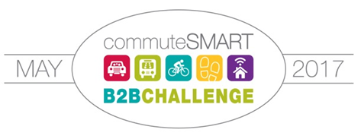
Welcome back to the 24 returning teams from 2016 year!!
- Amadeus
- Bowst
- Calypso Communications
- City of Portsmouth
- City of Rochester
- COAST
- Heinemann Publishing
- IAPP (International Assoc. of Privacy Professionals)
- Loftware
- Lonza
- LTC Partners
- National Passport Center
- NH Dept. of Environmental Services
- Oak Point Associates
- Papa Wheelies
- PAX World Fund
- Pease Development Authority
- Rockingham Planning Commission
- Strafford Regional Planning Commission
- Sun Life Financial
- Timberland
- TMS Architects
- Vital Design
And a hearty welcome to the new teams!!
- Eastern Mountain Sports
- Gundalow Company
- Greater Portsmouth Chamber of Commerce
- Harbour Light Strategic Marketing
- Hilton Garden Inn
- Langdon Place
- Little Harbor School
- Medtronic
- Northeast Credit Union
- Portsmouth High School
- Portsmouth Naval Shipyard
- Portsmouth Middle School
- UNH

