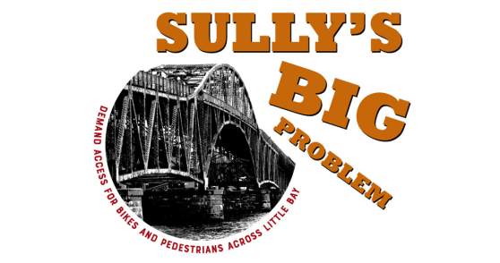
UPDATE ON SULLY (General Sullivan Bridge)
- NHDOT is leaning towards partial rehab – keeping the piers but replacing the entire cement and steel superstructure with something narrower and smaller. This will cost an estimated $31.5 million, the most cost effective of four options over a 70 year period.

- Federal highway funds spent on widening the Spaulding were contingent on the rehab of Sully in its current form. NHDOT will have to reopen the approval process with FHA and NH Dept. of Historic Resources, who will probably oppose it and kick it down to DC.

- NHDOT is preparing a supplemental environmental impact statement, including a public information meeting to be held in Dover City Hall in November/December 2017 (“to overview the construction options”) and another one in the summer of 2018 (“to outline the direction to be recommended and how they will maintain access during construction”).

- Dover’s Sen. David Watters sits on the Senate Transportation Committee and supports maintaining bike/ped access across Little Bay. He stated, “What’s important is that we have to make sure there’s a crossing there,” but warns that this will need to be sold to the legislature in the NHDOT 10-year Transportation Plan during the 2018 session. (Written testimony can be sent to William E. Watson, P.E., NHDOT, P.O. Box 483 Concord, NH 03302-0483 until Nov. 6th, 4pm.)

- Bike/ped access during 2-3 years of construction will be a shuttle bus or southbound lane in the new Little Bay bridge. Keith Cota, project manager for NHDOT said that they were leaning towards a shuttle bus as the cheapest solution. Regardless, he says, “There will be hardships imposed…it will likely be to the bicyclist that likes ‘speed’ and no disruptions.” Whatever that means.

- NHDOT does not have a contingency plan if Sully is deemed unsafe for travel before construction is scheduled to begin June, 2019.

- 500 – 1000 people use Sully per week during the summer. (NH DOT 2016 & 2017 counts)

- SABR does not support the shuttle bus option for access during construction; instead supports a two-way protected bike path on the southbound side of the Little Bay Bridge.

