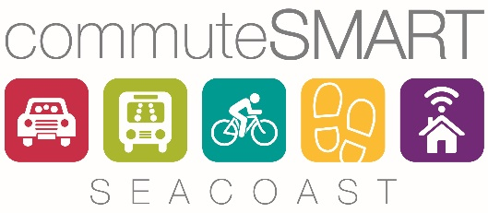
Thank you for your interest in joining commuteSMARTseacoast!
Please complete this form and return to info@commutesmartseacoast.org

MEMBERSHIP FORM
Company Name Click here to enter text. Date Click here to enter a date.
Street Address Click here to enter text. City Click here to enter text. State Click here to enter text. Zip Click here to enter text.
Contact person Click here to enter text. Title Click here to enter text.
Email Click here to enter text. Phone Click here to enter text.
Number of employees Click here to enter text. (full time) Click here to enter text. (part time)Click here to enter text.

Please enter Yes or No for any of the following FREE CommuteSMART Seacoast services you are interested in receiving:
Click here to enter text. Surveying and analyzing employee commuting patterns and needs
Click here to enter text. On-site informational events
Click here to enter text. Employee registration for Emergency Ride Home Benefit
Click here to enter text. Printed literature about commuter options and resources.
Click here to enter text. Quarterly newsletter
Click here to enter text. Information on regional commuter events/contests (e.g. Bike/Walk to Work Week, Conquer the Cold, Seacoast B2B Commuter Challenge)

For more information, contact us at: 603-994-3500 x104
info@commutesmartseacoast.org www.commuteSMARTseacoast.com

