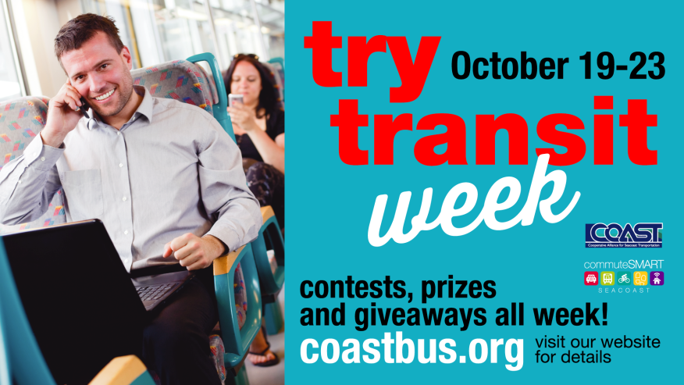

Monday, Oct. 19th^{h} Selfie on the bus
Why not take of selfie while you wait for the bus…ride the bus…board the bus? Post it on Twitter or Facebook with #COASTbus and you will receive a two free COAST bus tickets. For each photo you post, you will be entered into a raffle for a free monthly bus pass ($52 value).
Tuesday, Oct. 20th Sticker Day!
The first 1,000 riders get a free “I rode the bus” sticker to proudly wear.
Wednesday, Oct. 21st Best Photo While Riding COAST
Perhaps you’ve taken a photo of an awesome sunset, a blur of car lights on the Spaulding Turnpike, or people in Market Square from your window on a COAST bus. Post it on Twitter or Facebook with #COASTbus and you will receive a two free COAST bus tickets. For each photo you post, you will be entered into a raffle for a free monthly bus pass ($52 value).
Thursday, Oct. 22nd Operator Appreciation Day
Take a moment to let your favorite driver how much you appreciate him or her!
Friday, Oct. 23rd Rider Appreciation Day
All COAST riders are in for a nice surprise and a great way to end the week!
