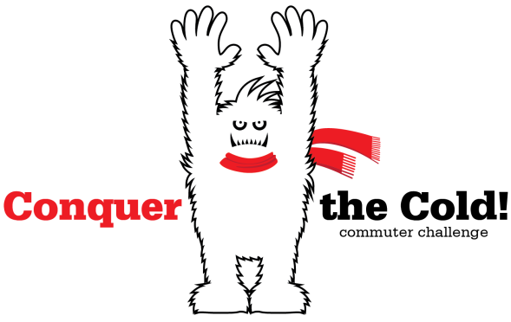
Get rewarded for biking, walking and taking the bus to work this winter Nov. 1 – Jan. 31
Challenge yourself to do more biking, walking, or taking the bus to work this winter. You’ll receive prizes, be entered into raffles for even bigger prizes, AND save money while protecting the environment. Sounds good, right?!
“Conquer the Cold”, sponsored by commuteSMARTseacoast, is a fun and FREE winter commuter challenge for people who work in the Greater Seacoast region of New Hampshire. Register online and start logging your sustainable trips from Nov. 1st – Jan. 31st . You will earn badges and prizes the more trips you log. And be entered into a raffle for three grand prizes.

Snow flake 1-15 round trips.
Get cool stickers & show off your smart commuting effort!
Icicle 16-30 round trips
Receive a pair of HotHands ® hand warmers to slip into your gloves!

Hot Chocolate 31-45 round trips
Earn a Dunkin’ Donut gift card for a hot drink to warm you up!

Abominable Snowman 46+ round trips
Win an Abominable Snowman mug.

Grand prize raffle. Every time you log a trip, your name will be entered into the raffle drawing. Three smart commuters will win a $250 gift card or $250 worth of COAST bus passes. Drawing to be held Feb. 1st.

Plus there will be other fun contests – “Name the Yeti” and “Where’s Yeti?” to win more prizes. Follow us on Facebook and Twitter for details!

Click here to sign up today!

Disclaimer: Bicycling, walking, and taking the bus are reliable and affordable forms of year-round transportation. However, you may get cold and perhaps frustrated depending on the conditions. There is a learning curve, so please read the information on our website and talk to other cold weather commuters.

PLEASE BE SAFE! Use your smarts and commute within your comfort level. Be aware of changing weather and temperatures that may create black ice. Have a back-up plan if you aren’t comfortable finishing your commute.

COAST and any business or organization involved with the Conquer the Cold Challenge is not responsible for any harm caused to an individual or their property due to participation in the Challenge.

