**How to Add CommuteSMART App to Your Phone**

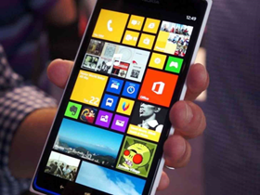

**iPhone**

* Grab your iPhone
* Open your browser (Safari)
* Go to our website [www.commuteSMARTseacoast.org](http://www.commuteSMARTseacoast.org)
* Select the share icon at very bottom of the screen (shown below)  
    
    
  
* A menu will slide up
* Find an option called "Add to Home Screen" (see below)

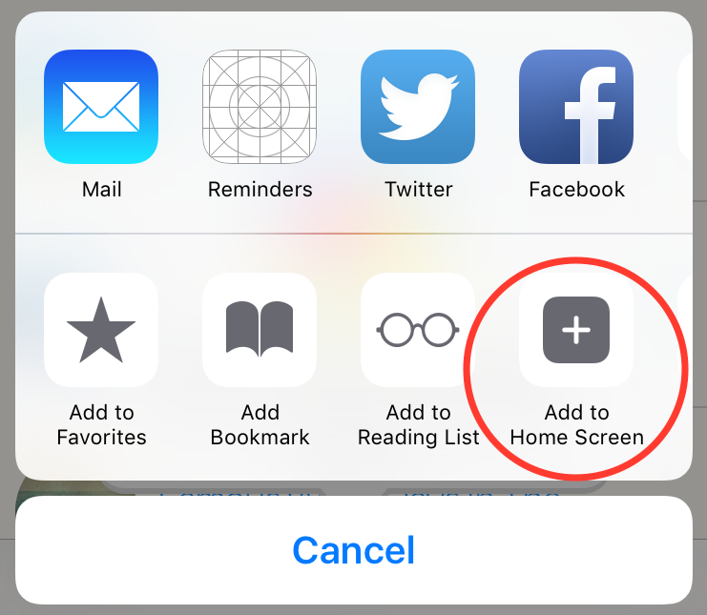

* Select it
* Now close your browser
* And presto, a nice icon appears on your phone (look around, it should be there)
* Then you simply select that icon and it takes you to the website anytime you like

**Android**

* Open your browser
* Go to [commuteSMARTseacoast.org](http://www.commutesmartseacoast.org)
* Log in into your account
* From your browser
* Select "Add shortcut to Home"
* Select "Add"

The CommuteSMART icon will now appear on your home screen. Just select the icon to use CommuteSMART!