Weekly Cheerleading Guide
Tuesday, April 3rd
Poster #1
EMAIL BLAST #1: “Join the Commute Smart B2B Challenge May 1st – 31st!”
Have you heard?! Our company is competing in the upcoming Commute Smart B2B (Business to Business) Challenge and I’m (we’re) the team captain(s). It’s a fun contest to use sustainable transportation during the month of May.
All you have to do is commute to work using any mode other than driving alone (e.g. carpooling, riding your bike or moped, walking, taking the bus, skateboarding, or working from home).
You register online and then log your trips throughout the month of May. You don’t have to commute smart every day...whatever works for your schedule.
You’ll get fun swag, a coffee gift card, and a chance to win raffle prizes. And money in your pocket from savings on gas, tolls, and maintenance. And you’ll be helping the environment!
Not sure about sustainable commuting options? For more information and commuting tips
click here or call Anne Rugg at 603-953-3176. Click here to find a carpool buddy on a secure statewide data base.

Join our team and be part of the smartest, greenest workforce in the Seacoast.

Your wallet and your planet thank you!
Sincerely,
XXXX
Captain, Team XXXXX

P.S. If you participated last year, you don’t need to sign up again. But please let me know you’re in again! If you can’t remember your user name or password, email arugg@commuteSMARTseacoast.org.
P.P.S. Challenge another company in the greater Seacoast of NH to join the fun! If they participate, CommuteSMART will send you a $50 gift card to Portsmouth a la Carte that includes Portsmouth’s most popular restaurants, shops, theaters, spas and more.
___________________________________________________________________________

Tuesday, April 10th
EMAIL BLAST #2: Introducing Supra – the smart commuting super hero!
This year we have an awesome mascot and cheerleader for the Commute Smart B2B Challenge. Supra, short for Supra Smart Commuter, is super psyched about the upcoming Challenge! A life sized version will be on site, XXXX, for you to take a selfie with our Super Hero mascot!
Supra sends a big thanks and high five if you’re new or returning to our team.
If you haven’t signed up yet, here’s the link to the easy-peasy sign up page.
Every trip and every mile you commute sustainably puts money in your pocket and shrinks your carbon footprint. And doing it as a team (and getting fun prizes!) makes it FUN. Super fun!
If you need help in finding a carpool buddy, ask around, stick a pin and your name in the carpool matching map haning in XXX, or go to the secure on-line matching database at CommuteSMART.
Let’s make this fun!

P.S. Challenge another company in the greater Seacoast of NH to join the fun! If they participate, CommuteSMART will send you a $50 gift card to Portsmouth a la Carte that includes Portsmouth’s most popular restaurants, shops, theaters, spas and more.
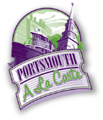
___________________________________________________________________________

Tuesday, April 24th
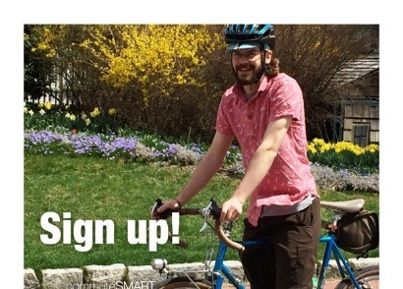 Poster #2
EMAIL BLAST #3: “Don’t miss out – only 1 week left to join our team”
Don’t miss out!
There’s only one week before the Commute Smart B2B Challenge! It kicks off next Tuesday, May 1st^{th} and runs through May 31st.
Click this link to join our team and be part of the smartest, greenest workforce by carpooling, vanpooling, riding your bicycle, skateboard or moped, walking, taking the bus, or teleworking!
Get swag and win prizes!
Getting to work has never been so much fun!
P.S. If you’ve already joined our team, thanks so much!
___________________________________________________________________________
Tuesday, May 1st
EMAIL BLAST #4: “Let the games begin!”
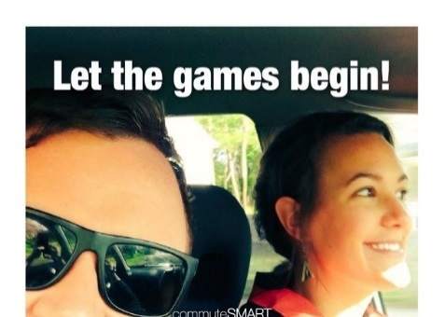 Poster #3
Today is the first day of the Commute Smart B2B Challenge! Thanks so much for joining our team.
You log your trips here.
As the Challenge progresses, you will see how our team stands in real time ranking on a leaderboard. When you click on our team name, you’ll see your individual ranking.
Getting to work has never been so much fun!
Have you met Supra yet…the fearless Super-smart commuter and mascot of the challenge.
P.S. Do you have anything to share on social media about your smart commute? Use #CommuteToWin and our company name. We could win a prize for most social media buzz!
Highlights of the social media posts are posted below the Challenge leaderboard.
___________________________________________________________________________
Tuesday, May 8th No poster.
Email blast #5: “We’re in it to WIN IT!”
It’s Week Two of the Commuter B2B Challenge and we’ve got X# people on our team! We are carpooling, riding our bikes/skateboards/mopeds, walking, taking the bus, and teleworking.
Check out the leaderboard to see how much money we’re all putting in our pockets and helping to reduce carbon emissions. Now that’s smart!
When you click on the leaderboard, click on our team name to see where you are in relation to your teammates. Click on your name and see all of your trips. If you’ve logged a duplicate trip, you can delete it yourself.
Are you getting into the habit of logging your trips? Most folks do it as they start their work day in the morning or during lunch.
If you haven’t received your “Thanks for Logging your First Trip” gift, please (insert instructions here).

P.S. Do you have anything to share on social media about your smart commute? Use #CommuteToWin and our company name. We could win a prize for most social media buzz! Check out highlights of the social media posts below the Challenge leaderboard.
___________________________________________________________________________

Tuesday, May 15th
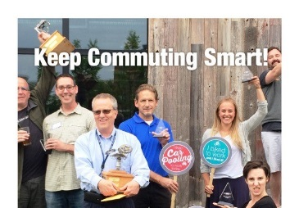Poster #4
Email blast #6: “It’s Raffle Time for Smart Commuters!”
Thanks for commuting sustainably during the last two weeks! You are doing your part to help reduce carbon emissions and put money in your pocket. Very smart!
We have # number of cool raffle prizes (you may want to list them) from CommuteSMART! (Insert your raffle details – date and how to get their prize).
Are you keeping up with logging your trips? If you don’t log, it didn’t happen!
Check out the leaderboard to see how much money we’re all putting in our pockets and helping to reduce carbon emissions. Now that’s smart!
When you click on the leaderboard, click on our team name to see where you are in relation to your teammates. Click on your name and see all of your trips. If you’ve logged a duplicate trip, you can delete it yourself.

P.S. It’s a numbers game….the more trips you’ve logged, the better your chances for winning a raffle prize.
___________________________________________________________________________
Tuesday, May 22rd No poster
Email blast #7: It’s time for ANOTHER raffle
More fun this week for smart commuters – a raffle with some great prizes will be held on _____.
The more trips you logged, the greater your chance to win (list the prizes).
As we enter the fourth week of the Challenge, I want to thank you for your effort in commuting smart and logging your trips. Let’s please keep up our effort – we don’t want to slip in the standings!
___________________________________________________________________________

Tuesday, May 29th no poster
Email Blast #8: “Only 3 days left…have you logged all your trips?!”
Hope you had a fabulous Memorial Day Weekend!
Now we’re back to work and only three more days to the finish line! Thanks for all your effort for our team!
Don’t forget to log your trips here. If you didn’t log, it didn’t happen!
P.S. You’re invited to the celebration party on Thursday, June 7th at 3S Artspace, 319 Vaughan St., Portsmouth for free munchies from 5-7pm. RSVP to me please.
___________________________________________________________________________
Friday, June 1st
Email blast #9: “Thanks for commuting smart!”
Thanks to everyone on Team _______ for your great effort in the Commute Smart B2B Challenge. We placed ____ in the most sustainable trips category. List any other awards here.
Everyone who participated will receive a Dunkin Donuts gift card. (insert instructions for getting their card.)
Just because the Challenge is over, that doesn’t mean that you should stop commuting sustainably.
To continue the fun (and competition!) CommuteSMART will be holding a summer challenge called, DUMP THE PUMP from June 1 – Aug. 31. This challenge is open to everyone in the greater seacoast and it’s an individual, not a team event.

Again, thanks so much for commuting smart!

