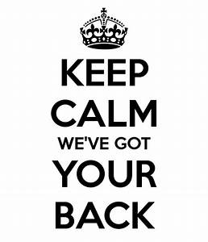
Our job is to make your job as Team Captain as easy (and fun!) as possible. CommuteSMART will support you by providing:
- Emails (Monday and Friday) including:
  - Instructions for that week
  - Sample email blast
  - Poster
  - Q&A from team captains
  - Registration list
  - Updates on the “Bike Only” competition within the B2B Challenge

- List of last year’s team members and contact info

- Swag
  - For everyone who logs a trip
  - Raffle items (the quantity depends on the number of team members logging by April 13th)

- Answers to your questions & help with outreach strategies

- Supra, our life sized Super Hero, delivered to your office for a kick-off event or just for fun

