Weekly Cheerleading Guide – Sample Emails
Note: Any text in red means you need to customize it for your workplace.
Tuesday, April 2rd EMAIL BLAST #1: “Join the Commute Smart B2B Challenge May 1st – 31s!”
Poster #1
Have you heard?! Our company(department) is competing in the upcoming Commute Smart B2B (Business to Business) Challenge and I’m (we’re) the team captain(s). It’s a fun contest to commute sustainably during the month of May.
All you have to do is commute to work using any mode other than driving alone (e.g. carpooling, riding your bike or moped, walking, taking the bus, skateboarding, or working from home).
You register online and then log your trips throughout the month of May. You don’t have to commute smart every day...whatever works for your schedule.
You’ll get fun swag, a coffee gift card, and a chance to win raffle prizes. And money in your pocket from savings on gas, tolls, and maintenance. Most importantly, you’ll be helping the environment by shrinking your carbon footprint!
Not sure about sustainable commuting options? For more information and commuting tips
click here or call Anne Rugg at 603-953-3176. Click here to find a carpool buddy on a secure data base.

Join our team and be part of the smartest, greenest workforce in the Seacoast.

Your wallet and your planet thank you!
Sincerely,
XXXX
Captain, Team XXXXX

P.S. There’s a new, improved leaderboard, so you’ll need to sign up again (unless you competed in the Conquer the Cold Challenge). Now you can correct any logging error and it’s much easier to log multiple trips. (New teams disregard this!)
P.P.S. Challenge another company in Seacoast NH to join the Challenge! If they participate, CommuteSMART will send you a gift card to Portsmouth a la Carte. It’s the “fun card” that includes Portsmouth’s most popular restaurants, shops, theaters, spas and more. Email arugg@commutesmartseacoast.org with the details of your referral.
_____________________________________________________________________________________________
Tuesday, April 9th EMAIL BLAST #2: Introducing Supra – the smart commuting super hero!
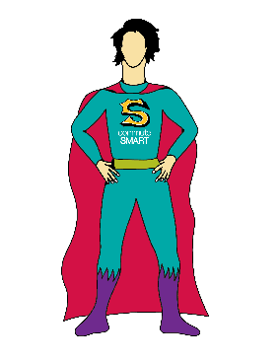
Meet Supra, our awesome mascot and cheerleader for the Commute Smart B2B Challenge. Supra, short for Supra Smart Commuter, is super psyched about the upcoming Challenge! A life sized version will be on site, date/time, for selfies!
Supra sends a big thanks and high five if you’re new or returning to our team.
If you haven’t signed up yet, here’s the link to the easy-peasy sign up page.
Every trip and every mile you commute sustainably puts money in your pocket and shrinks your carbon footprint. And doing it as a team (and getting fun prizes!) makes it FUN. Super fun!
If you need help in finding a carpool buddy, ask around, stick a pin and your name in the carpool matching map hanging in XXX, or go to the secure on-line matching database at CommuteSMART.
Let’s make this fun!
P.S. There’s a new, improved leaderboard, so you’ll need to sign up again (unless you competed in the Conquer the Cold Challenge). Now you can correct any logging error and it’s much easier to log multiple trips. (New teams disregard this!)
P.P.S. Challenge another company in the greater Seacoast of NH to join the fun! If they participate, CommuteSMART will send you a gift card to Portsmouth a la Carte. It’s the “fun card” that includes Portsmouth’s most popular restaurants, shops, theaters, spas and more. . Email arugg@commutesmartseacoast.org with the details of your referral.

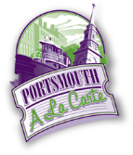
_____________________________________________________________________________________________
Tuesday, April 23th EMAIL BLAST #3: “Don’t miss out – only 1 week left to join our team”
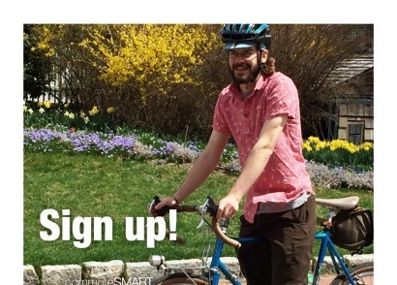 Poster #2
Don’t miss out!
There’s only one week before the Commute Smart B2B Challenge! It kicks off May 1st^{th} and runs through May 31st.
Click this link to join our team and be part of the smartest, greenest workforce by carpooling, vanpooling, riding your bicycle, skateboard or moped, walking, taking the bus, or teleworking!
Get swag and win prizes!
Getting to work has never been so much fun!
If you’ve already joined our team, thanks so much!
P.S. You’re invited to the Challenge Kick-off at the Portsmouth Brewery, 56 Market St., Portsmouth (downstairs at the Jimmy LaPanza Lounge) on Wednesday, May 1st from 5:30 -7pm. Free munchies, cash bar, door prizes. Meet other smart commuters!!
___________________________________________________________________________

Wednesday, May 1st EMAIL BLAST #4: “Let the games begin!”
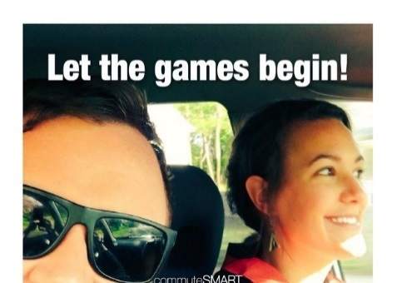 Poster #3
Today is the first day of the Commute Smart B2B Challenge! Thanks so much for joining our team.
You log your trips here.
As the Challenge progresses, you will see how our team stands in real time ranking on a leaderboard. When you click on our team name, you’ll see your individual ranking.
Getting to work has never been so much fun!
Have you met Supra yet…the fearless Super-smart commuter and mascot.
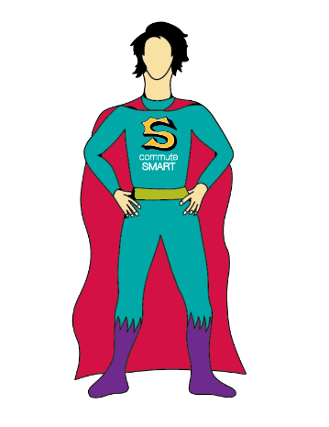
P.S. Do you have anything to share on social media about your smart commute? Use #CommuteToWin and our company name. We could win a prize for most social media buzz!
Highlights of the social media posts are posted below the Challenge leaderboard.
P.P.S. Reminder – TONIGHT May1st! Challenge Kick-off at the Portsmouth Brewery, 56 Market St., Portsmouth (downstairs at the Jimmy LaPanza Lounge) from 5:30 -7pm. Free munchies, cash bar, door prizes. Meet other smart commuters!!
___________________________________________________________________________

Tuesday, May 8th No poster. Email blast #5: “We’re in it to WIN IT!”
Great job commuting to work using a sustainable mode! Thanks so much for being part of our team and reducing your carbon footprint. Pat yourself on your back!!
We’ve got X# people on our team so far and it’s not too late to sign up. We’re carpooling, riding our bikes/skateboards/mopeds, walking, taking the bus, and teleworking.
Check out the leaderboard to see how much money we’re all putting in our pockets and helping to reduce carbon emissions. Now that’s smart!
When you click on the leaderboard, click on our team name to see where you are in relation to your teammates. Click on your name and see all of your trips. If you’ve logged a duplicate trip or incorrect date, you can correct it yourself.
Are you getting into the habit of logging your trips? Most folks do it as they start their work day or during lunch.
If you haven’t received your “Thanks for Logging your First Trip” gift, (insert instructions here).
P.S. Do you have anything to share on social media about your smart commute? Use #CommuteToWin and our company name. We could win a prize for most social media buzz!
___________________________________________________________________________
Tuesday, May 15th Email blast #6: “It’s Raffle Time for Smart Commuters!”
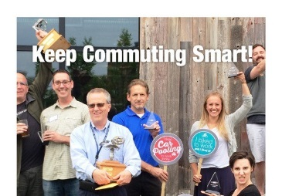Poster #4
Thanks for commuting sustainably during the last two weeks! You are doing your part to help reduce carbon emissions and put money in your pocket. Very smart!
We have some cool raffle prizes (you may want to list them) from CommuteSMART! (Insert your raffle details – date and how to get their prize).
Are you keeping up with logging your trips? If you don’t log, it didn’t happen!
Check out the leaderboard to see the stats.
When you click on the leaderboard, click on our team name to see where you are in relation to your teammates. Click on your name and see all of your trips. If you’ve logged a duplicate trip, you can delete it yourself.
Do you have anything to share on social media about your smart commute? Use #CommuteToWin and our company name. We could win a prize for most social media buzz!
P. S. Attention bicyclists and walkers! Friday, May 17th is National Bike/Walk to Work Day. Visit one of the ten free breakfasts held in the Seacoast. Click here for more information.
____________________________________________________________________________________________
Tuesday, May 21st No poster Email blast #7: “Let’s Keep up the Momentum!”
As we enter the fourth week of the Challenge, I (we)want to thank you for your effort in commuting smart.
Let’s please keep up the momentum and log your trips – we don’t want to slip in the standings!
P.S. Let’s get social! Do you have anything to share on social media about your smart commute? Use #CommuteToWin and our company name. We could win a prize for most social media buzz!
___________________________________________________________________________
Tuesday, May 28th no poster Email Blast #8: “Only 3 days left…have you logged all your trips?!”
Hope you had a fabulous Memorial Day Weekend!
Now we’re back to work and only three more days to the finish line! Thanks for all your effort for our team (and the planet)!
Don’t forget to log your trips here. If you didn’t log, it didn’t happen!
P.S. You’re invited to the celebration party on Tuesday, June11th, 5:30 -7pm at 3S Artspace, 319 Vaughan St., Portsmouth. Free munchies, cash bar and awards! RSVP to me please.
___________________________________________________________________________
Friday, May 31st Email blast #9: “LAST DAY!”
Thanks to everyone on Team _______ for your great effort in the Commute Smart B2B Challenge.
Today is the LAST DAY to log your trips. If you didn’t log it, it didn’t happen!
Everyone who participated will receive a Dunkin Donuts gift card. (insert instructions.)
Just because the Challenge is over, that doesn’t mean that you should stop commuting sustainably.
To continue the fun (and competition!) CommuteSMART will be holding a summer challenge, DUMP THE PUMP, from June 1 – Aug. 31. This challenge is open to everyone in the greater seacoast and it’s an individual, not a team event.
Thanks so much for commuting smart and participating in the Challenge!
P.S. You’re invited to the celebration party on Tuesday, June11th, 5:30 -7pm at 3S Artspace, 319 Vaughan St., Portsmouth. Free munchies cash bar, awards. RSVP o me please.

