Hints and Tips for Winter Commuting
Bicycling
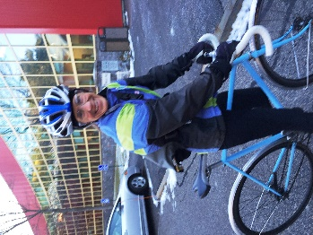
- Winter Biking Tips infographic
- “Why Ride Year Round?” – fun article by Bike Winter
- “Rules of Winter Cycling” by Bike Winter
- “Clothing for Winter Cycling” by Bike Winter
- “Winter Cycling” Great in-depth article from BicyclingLife website
- Exclusive Bike to Work coloring page by local artist Eric Ebbeson

Walking
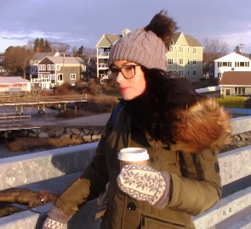
- Exclusive Walk to Work coloring page by local artist Eric Ebbeson
- Winter Walking Tips infographic
- 10 Tips for Walking in Cold Weather
- Safe Winter Walking by SIMA

Riding the Bus
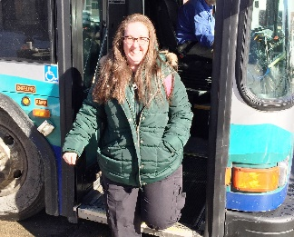
- Bus schedules from COAST and Wildcat Transit
- Tips on riding the bus in winter.
- Exclusive Bus to Work coloring page by local artist Eric Ebbeson

