Weekly Cheerleading Guide – Sample Emails
Note: Any text in red means you need to customize it for your workplace.
Tuesday, April 7 EMAIL BLAST #1: “Join the Commute Smart B2B Challenge May 1st – 31s!”
Poster #1
Have you heard?! Our company(department) is competing in the upcoming Commute Smart B2B (Business to Business) Challenge and I’m (we’re) the team captain(s). It’s a fun contest to commute sustainably during the month of May.
Commute to work using any mode other than driving alone (e.g. carpooling, riding your bike or moped, walking, taking the bus, skateboarding, or working from home).
Register online and log your trips throughout the month of May. You don’t have to commute smart every day...whatever works for your schedule.
You’ll get fun swag, a coffee gift card, and a chance to win raffle prizes. And money in your pocket from savings on gas, tolls, and maintenance. Most importantly, you’ll be helping the environment by shrinking your carbon footprint!
Not sure about sustainable commuting options? For more information and commuting tips
click here or call Anne at CommuteSMART Seacoast, 603-953-3176. Click here to find a carpool buddy on a secure data base.

Join our team and be part of the smartest, greenest workforce in the Seacoast.

Your wallet and your planet thank you!
Sincerely,
XXXX
Captain, Team XXXXX

P.S. Challenge another company in Seacoast NH to join the Challenge! If they participate, CommuteSMART will send you a gift card to Portsmouth a la Carte. It’s the “fun card” that includes Portsmouth’s most popular restaurants, shops, theaters, spas and more. Email arugg@commutesmartseacoast.org with the details of your referral.
_____________________________________________________________________________________________
Tuesday, April 14 EMAIL BLAST #2: Introducing Supra – the smart commuting super hero!
Meet Supra, our super-hero mascot and cheerleader for the Commute Smart B2B Challenge. Supra is super psyched about the upcoming Challenge! A life sized version will be on site, date/time, for selfies!
Supra sends a big thanks and high five for signing up!
If you haven’t signed up yet, here’s the link to the easy-peasy sign up page.
Every trip and every mile you commute sustainably puts money in your pocket and shrinks your carbon footprint. And doing it as a team (and getting fun prizes!) makes it FUN. Super fun!
If you need help in finding a carpool buddy, ask around, stick a pin and your name in the carpool matching map hanging in XXX, or go to the secure on-line matching database at CommuteSMART.
Let’s make this fun…you’ve got this!
P.S. Challenge another company in the greater Seacoast of NH to join the fun! If they participate, CommuteSMART will send you a gift card to Portsmouth a la Carte. It’s the “fun card” that includes Portsmouth’s most popular restaurants, shops, theaters, spas and more. . Email arugg@commutesmartseacoast.org with the details of your referral.

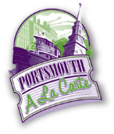
_____________________________________________________________________________________________

Tuesday, April 21 EMAIL BLAST #3: “Don’t miss out –join our team”
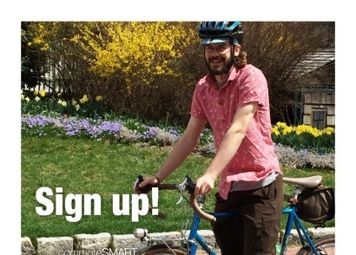 Poster #2
Don’t miss out!
The Commute Smart B2B Challenge will start very soon! It kicks off May 1st^{th} and runs through May 31st.
Click here to join our team and be part of the smartest, greenest workforce by carpooling, vanpooling, riding your bicycle, skateboard or moped, walking, taking the bus, or teleworking!
Get swag and earn prizes! Getting to work has never been so much fun.
If you’ve already joined our team, thanks so much!
P.S. You’re invited to the Challenge Kick-off at the Portsmouth Brewery, 56 Market St., Portsmouth (downstairs at the Jimmy LaPanza Lounge) on Friday, April 30th from 5:30 -7pm. Free munchies, cash bar, door prizes. Meet other smart commuters!! THIS WILL PROBABLY BE CANCELED.
___________________________________________________________________________
Friday, May 1 EMAIL BLAST #4: “Let the games begin!”
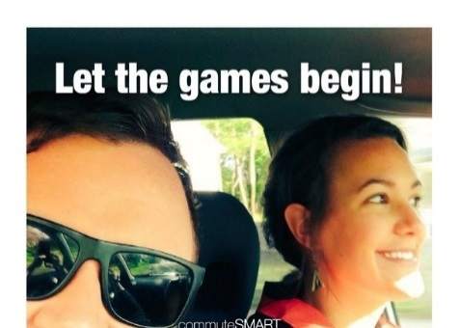 Poster #3
Today is the first day of the Commute Smart B2B Challenge! Thanks so much for joining our team.
Log your trips here. You can log ahead 5 days.
As the Challenge progresses, you’ll see how our team stands in real time ranking on a leaderboard. When you click on our team name, you’ll see your individual ranking.
Getting to work has never been so much fun!
Have you met Supra yet…the fearless Super-Hero, smart commuting, mascot!
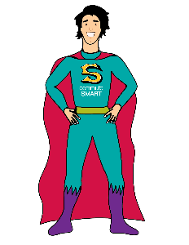
P.S. Do you have anything to share on social media about your smart commute? Use #CommuteToWin and our company name. We could win a prize for most social media buzz!
Highlights of the social media posts are posted below the Challenge leaderboard.
___________________________________________________________________________
Tuesday, May 5 No poster. Email blast #5: “We’re in it to WIN IT!”
Great job commuting to work sustainably! Thanks so much for being part of our team and reducing your carbon footprint.
We’ve got X# people on our team so far and it’s not too late to sign up. We’re carpooling, riding our bikes/skateboards/mopeds, walking, taking the bus, and teleworking.
Log your trips here. You can log ahead 5 days, or back log to May 1st.
Check out the leaderboard to see how much money we’re all putting in our pockets and helping to reduce carbon emissions. Now that’s smart!
When you click on the leaderboard, click on our team name to see where you are in relation to your teammates. Click on your name to see all of your trips. If you’ve logged a duplicate trip or incorrect date, you can correct it yourself.
Are you getting into the habit of logging your trips? Most folks do it as they start their work day or during lunch.
If you haven’t received your “Thanks for Logging your First Trip” gift, (insert instructions here).
P.S. Do you have anything to share on social media about your smart commute? Use #CommuteToWin and our company name. We could win a prize for most social media buzz!
___________________________________________________________________________

Tuesday, May 12 Email blast #6: “Commuting Sustainably,,, so smart and FUN”
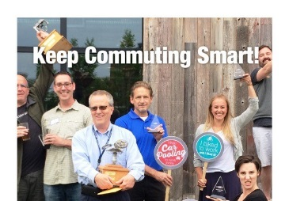Poster #4
Thanks for commuting sustainably! You’re doing your part to help reduce carbon emissions and put money in your pocket. Very smart!
Have you logged all your trips? If you don’t log, it didn’t happen! You can log ahead 5 days, or back log to May 1st.
Check out the leaderboard to see the stats.
When you click on the leaderboard, click on our team name to see where you are in relation to your teammates. Click on your name and see all of your trips. If you’ve logged a duplicate trip, you can delete it yourself.
Do you have anything to share on social media about your smart commute? Use #CommuteToWin and our company name. We could win a prize for most social media buzz!
P. S. Attention bicyclists and walkers! Friday, May 15th is National Bike/Walk to Work Day. Visit one of the ten free breakfasts held in the Seacoast. Click here for more information.
____________________________________________________________________________________________
Tuesday, May 19 No poster Email blast #7: “It’s Raffle Time for Smart Commuters!”
As we enter the third week of the Challenge, I (we)want to thank you for your effort in commuting smart.
Have you logged all your trips? If you don’t log, it didn’t happen! You can log ahead 5 days, or back log to May 1st.
Let’s please keep up the momentum and log your trips – we don’t want to slip in the standings!
We have some cool raffle prizes (you may want to list them) from CommuteSMART! (Insert your raffle details – date and how to get their prize).
P.S. Let’s get social! Do you have anything to share on social media about your smart commute? Use #CommuteToWin and our company name. We could win a prize for most social media buzz!
___________________________________________________________________________

Tuesday, May 26 no poster Email Blast #8: “Only 4 days left…have you logged all your trips?!”
Hope you had a fabulous Memorial Day Weekend!
There’s only four more days to the finish line! Thanks for all your effort for our team (and the planet)!
Don’t forget to log your trips here. If you didn’t log, it didn’t happen! You can back log to May 1st.
P.S. You’re invited to the celebration party on Wednesday, June 17th, 5:00 – 6:30 pm at 3S Artspace, 319 Vaughan St., Portsmouth. Free munchies, cash bar and awards! RSVP to me please. This event may be cancelled.

___________________________________________________________________________
Friday, May 29 Email blast #9: “LAST DAY!”
Thanks to everyone on Team _______ for your great effort in the Commute Smart B2B Challenge.
Have you logged all your trips? If you don’t log, it didn’t happen! You can log ahead 5 days, or back log to May 1st. You have until midnight, on Wednesday June 3rd to log your trips.
The challenge will be over on May 31st. Everyone who participated will receive a coffee gift card. (insert instructions.)
Just because the Challenge is almost over, that doesn’t mean that you should stop commuting sustainably.
Thanks so much for commuting smart and participating in the Challenge!
P.S. You’re invited to the celebration party on Wednesday, June 17th, 5:00 – 6:30 pm at 3S Artspace, 319 Vaughan St., Portsmouth. Free munchies cash bar, awards. RSVP to me please.
This event may be cancelled.

