Weekly Cheerleading Guide
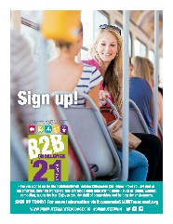Click here to download poster.
Wednesday, April 7th
EMAIL BLAST #1: “Join the Commute Smart B2B Challenge May 1st – 31st!”
Did you know our company is competing in the upcoming Commute Smart B2B (Business to Business) Challenge? It’s a fun contest to use sustainable transportation during the month of May.
All you have to do is commute to work using any mode other than driving alone (e.g. working from home, riding your bike or moped, walking, taking the bus, or carpooling). You register online and then log your trips throughout the month. You don’t have to commute smart every day...whatever works for your schedule.
You can get cool swag plus you’ll save money from savings on gas, tolls, and vehicle maintenance.
Not sure about sustainable commuting options? Visit www.commuteSMARTseacoast.org for more information and commuting tips.
Click here to join our team and be part of the smartest, greenest workforce. Or if you have competed before simply login here.
Your wallet and your planet will thank you!
Sincerely,
XXXX
Captain, Team XXXXX

P.S. Getting to work has never been so much fun!

Wednesday, April 14th
Resend Email blast #1 with a P.S. “If you’ve already signed up, thanks so much!”

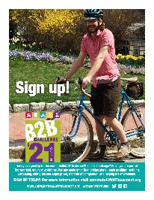 Click here to download poster.
Wednesday, April 21st
EMAIL BLAST #2: “Don’t miss out – only 1 week left”
Don’t miss out!
There’s only one and a half weeks before the Commute Smart B2B Challenge! It kicks off May 1st^{th} and runs through May 31st.
Click this link to join our team and be part of the smartest, greenest workforce by teleworking, bicycling, walking, bicycling, taking the bus, or carpooling! Or if you have competed before simply login here.
Getting to work has never been so much fun!
P.S. If you’ve already joined our team, thanks so much!

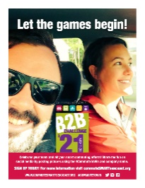Click here to download poster.
Monday, May 3rd
EMAIL BLAST #3: “Let the games begin!”
The B2B Challenge has begun! Thanks so much for joining our team.
Your pocketbook and your planet thank you for commuting smart.
You log your trips here. As the Challenge progresses, you will see how our team stands in real time ranking. When you click on our team name, you’ll see your individual ranking.
Getting to work has never been so much fun!
P.S. Do you have anything to share on social media about your smart commute? Use #CommuteToWin and our company name. We could win a prize for most social media buzz! Highlights of the social media posts are found below the Challenge leaderboard.

Tuesday, May 11th No poster
Email blast #4: “Having fun commuting smart!”
It’s Week Two of the Commuter B2B Challenge and we’ve got X# people on our team! We are telecommutin, bicycling, walking, taking the bus, and carpooling (you may need to edit these options) to save money and help the planet, and get exercise. Now that’s smart!
Are you getting into the habit of logging your trips? Most folks do it as they start their work day in the morning or during lunch.
P.S. Do you have anything to share on social media about your smart commute? Use #CommuteToWin and our company name. We could win a prize for most social media buzz! Check out highlights of the social media posts below the Challenge leaderboard.

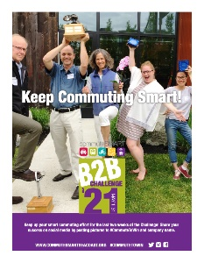Tuesday, May 18th Click here to download poster.
Email blast #5: “Keep up the good work!”
Thanks for commuting sustainably during the last two weeks! You are doing your part to help reduce carbon emissions and put money in your pocket. Very smart!
Are you keeping up with logging your trips? If you don’t log, it didn’t happen!

Tuesday, May 25th No poster
Email Blast #6: “Have you logged…only 6 days left in the Commuter Challenge!”
Only six more days to the finish line! Thanks for all your effort for our team!
Don’t forget to log your trips here.
P.S. You’re invited to a virtual celebration party! Details will be sent via team captains soon.

Monday, June 7th
Email blast #7: “Thanks for commuting smart!”
Thanks to everyone on Team _______ for your great effort in the Commuter Challenge. We placed ____ in the most sustainable trips category. List any awards here.
Just because the Challenge is over, doesn’t mean you should stop commuting sustainably.
Again, thanks so much for commuting smart!

